Updates for The Final Release Notes

Based on the feedback from Chunnip, we need to make the following changes:
1) The graph showing refinance eligibility vs current LTV looks reasonable to me.
2) Section 5 needs to be modified as we don't plan to store eligibility separately for conventional and FHA.

- Remove the section 5.

- Update section 6.1.1 Loan-level Replines
Proposed Changes. (Already implemented by IT) Separate our RE from non-RE loans in repline construction. As before, the incentive for the non-eligible loans is defined to be the unrestricted incentive. The incentive for the non-eligible loans will be the eligible incentive. That means assign the maximum incentive when eligible to both programs, but when only eligible to one program then only consider the incentive for that eligible program.

- Update section 6.1.2 Pool-level Replines
Proposed Changes. Pool level CDU files will be deprecated in Pricing and Risk Reports. As a goal for the March release, we want to switch the nightly reports from PL replines to LL. There is some time-consuming concern for the new approach, we will start to test and identify the bonds causing the issue. But the goal is to solve the potential issues and switch to the LL repline with a clear definition of Refi-Eligible and Non- Refi-Eligible.

- Update section 6.1.3 Single Repline
Current. There are two single repline versions: Pool Level single repline and Loan Level Single repline.

Proposed Changes. We want to switch the single replines to only Loan Level. The single repline will be divided into two records(replines). One for 100% refi-eligible, the other one for 0% refi-eligible.

3) For forward projection of incentive, there should be a decay when CLTV gets below 65 since the calculation of LLPA adjustment should be almost exact in that scenario.

- Update section 6.2 Forward Projections

ScaleConventionalIncentivet = ModelConventionalIncentivet + ConventionalAdj * DecayFacor(ƛ^{t})
ScaleFHAIncentivet = ModelFHAIncentivet + FHAAdj * DecayFacor(ƛ^{t})

Decay function. After enough equity growth, the model suggests that the bond should have low enough CLTV, which lead to 0 base LLPA and base PMI(base LLPA means the LLPA due to FICO and CLTV); however, at that point, the adjustment might still force the incentive to be more than 0 bps. Therefore, we model the adjustment as a decaying exponential factor, t, where t is units of time. We will need to find the optimized ƛ for the function.

=================================================================
Update 2/17/2018

As per Chunnip:
“For 5), I think there should be a dependence on CLTV as well since we know that the error will be small (may not necessarily zero) once CLTV gets below some threshold like 50.
One possibility is to create a curve S() which is a function of cltv. Suppose e_0 = initial incentive error with the corresponding initial cltv c_0. At time t, we have cltv_t and the projected
incentive error will be S(cltv_t)/S(cltv_0) * e_0. The S() should be a decreasing function and we should make it non-zero to avoid divison by zero (either by some exponential S-curve or simply a floor). Enclosed is a possible linear curve based on comparing the average LLPA per LTV bucket vs. the LLPA for the average FICO.”

Update section 5.2 Forward Projections
Giving us:
ScaleConventionalIncentivet = odelConventionalIncentivet + ConventionalAdj * DecayFacor
ScaleFHAIncentivet = ModelFHAIncentivet + FHAAdj * DecayFacor

As the MTM adjustment models the dispersion of the CDU incentive and Model incentive, this dispersion tend to decrease with CLTV goes down. Take the LLPA as an example:
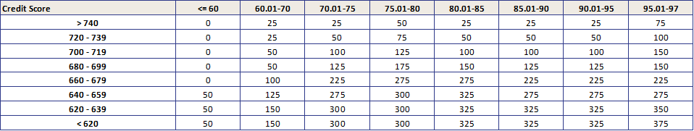
Assume the loans are uniformly distributed among all FICO groups, for each column we can get the average LLPA that saved in CDU:
On the other hand, Scale will use the average FICO for the model LLPA calculation. Let’s assume the average FICO is 690 in this case:
And hence get the dispersion for each CLTV bucket:
Generally, we can see the trend that the dispersion tend to decrease with CLTV goes down.

The result holds, as we assumed the CDU average FICO is 690 in this case. But the dispersion numbers will be different if the average FICO is different. We can introduce relative dispersion to handle this issue. Assume the highest dispersion 63 bps as 100%, the relative dispersion for each CLTV group will become:
In that table above, there is one small tweak we need to make: for CLTV group 75-80, the LLPA trend acts unusual. For now, let’s ignore the result for that bucket and plot the relative dispersion vs CLTV.
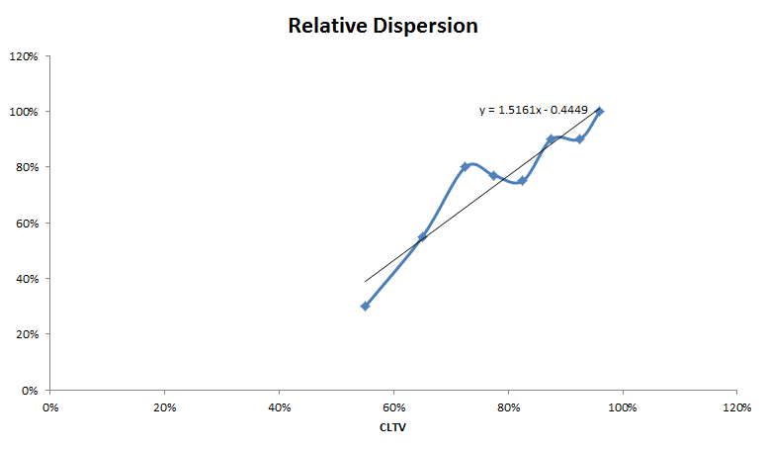
Based on that result, we can build a relative dispersion function RD() that can give us a % of adjustment for the given CLTV input, denote as RD(CLTV). The dispersion(or MTM adjustment) at time t can be derived as:
Adj_t = Adj_0 * [RD(CLTV_t) / RD(CLTV_0)]
Hence,
DecayFactor = RD(CLTV_t) / RD(CLTV_0)

Although we have proved there is a downward trend for the relative dispersion with CLTV decrease, the slope for that RD() function can be vary for different FICO distribution. As a simplification, we suggested to use a piecewise linear model for RD():
CLTV 0 to 50%: floor the RD as 5%
CLTV 50 to 97%: linear increase RD from 5% to 100%
CLTV 97 and above: cap the RD as 100%

